**Database Management System Final Project**

**Library Management System Database**

**University of Houston - Downtown**

**Final Phase**

**Tung Nguyen**

**Kinh Truong**

**Cooper Tran**

**Contribution Breakdown**

|  |  |  |
| --- | --- | --- |
| **Name** | **Contribution** | **Percentage** |
| Cooper Tran | Insert Database  Test Database  Debug  Report Drafting Format Report | 33.33% |
| Kinh Truong | Make ER Diagram  Insert Database  Test Database  Debug  Report Drafting  Error Document | 33.33% |
| Tung Nguyen | Create Database  Insert Database  Test Database  Debug  Report Drafting  Error Document | 33.34% |

# Table of content

Table of content 3

1. Abstract 4

2. Mission statement. 5

3. Mission objectives. 6

4. ER diagram 7

5. Relational model 8

6. Use cases 13

7. Use case implementation 24

8. Test plan and records 33

9. Conclusion 56

10. References 58

# Abstract

A database system for managing library resources at the University of Houston - Downtown has been developed collaboratively by Tung Nguyen, Kinh Truong, and Cooper Tran. This project aims to establish a Library Management System (LMS) that will assist librarians in performing multiple tasks simultaneously, such as organizing and sorting books, checking borrowing, and lending details, and collecting fines.

Through the LMS, all library processes could be managed in one place, allowing users to borrow or return books quickly without waiting in long lines. Librarians could easily add, view, update, or delete books and student information in the database using a single PC. Through the LMS, students and faculty can also locate books quickly on the shelves, making it easier to access library materials. As a library management system, the project offers all the essential features, and librarians can modify any data in the database once they are logged in. As a result of the LMS, the library management process could be streamlined and made more user-friendly, thereby saving both librarians and users time and effort.

# Mission statement.

A library database management system (DBMS) is essential for managing library resources. It facilitates librarians to easily create, update, and maintain records of library resources, and analyze data related to library usage and operations. The DBMS also increases the accuracy of tracking library items, ensuring that resources are available to patrons when needed, and provides quick access to information for users. By automating the process of checking out and returning books, the DBMS streamlines the circulation of library items, making it more organized and efficient. Overall, a library DBMS is crucial for maintaining a well-organized and effective library.

# Mission objectives.

A Library Database Management System (LDMS) mission is to provide necessary tool for a typical library branch to manage its facilities, as well as its components and staff. Using SQL, our mission is to provide quick, accurate and easy maintenance to IT staff of the library branch. For the first user of LDMS, staff members will be uniquely identified by StaffID to categorize whether they are managing staffs, floor staffs, or warehouse staffs. For each staff, they can access full LDMS; however, only managing staffs can modify books’ info and library’s facilities. For next users, members, LDMS will identify each member with their unique memberID. LDMS will also hold members’ information such as addresses, email, gender, email, phone numbers, and the amount of book loan they are currently under. All members’ information can be accessed by all staff of the library branch along with their loanID to process. Members and staff will have the same ability to renew/cancel membership as well as request a book. For books, LDMS will identify each book by their ISBN along with their titles, authors, publishing data as well as genre. By implementing LDMS into a library, operations can turn smoothly with little to no data redundancy, providing staff and members accurate data of library content. More than that, LDMS is important for managing staff to manage the existing and future inventory.

# ER diagram

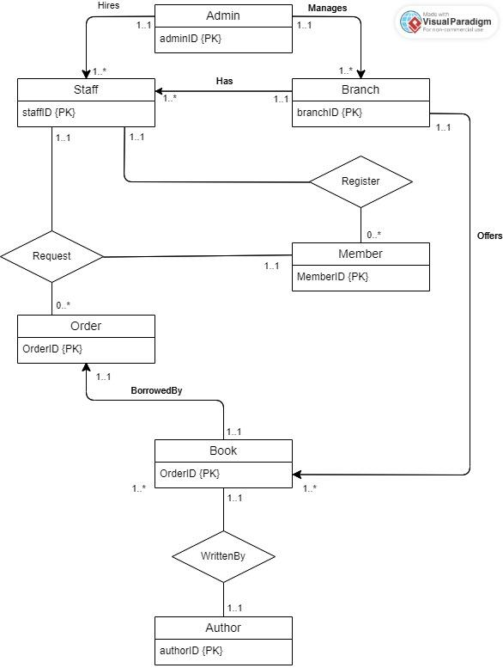

# Relational model

Branch (**branchID,** address, openHour, close Hour, openDay)

|  |
| --- |
| Branch |
| branchID {PK}  address  Open Hours  openHour  closeHour  openDay |

Admin(**adminID,** title, IName, fName, age, sex, email, branchID)

|  |
| --- |
| Admin |
| adminID {PK}  title  Name  lName  fName  age  sex  email |

Manage(**adminID,** branchID)

|  |
| --- |
| Manage |
| adminID {PK}  branchID {FK} |

**Normalization form/dependency:** for Branch, Admin and Manage tables, there are dependencies between these tables. Manage table references a foreign key constraint from both Admin table and Branch table. However, all three tables are in 3NF as they have no transitive dependency.

Staff(**staffID,** title, IName, fName, age, sex, email, branchID, hiredBy)

|  |
| --- |
| Staff |
| staffID {PK}  title  Name  lName  fName  age  sex  email  branchID {FK} |

hiring(**StaffID,** adminID)

|  |
| --- |
| hiring |
| staffID {PK}  adminID {FK} |

**Normalization form/dependency:** for Staff, Admin and hiring tables, there are dependencies when hiring columns consist foreign key constraints for other two tables. However, since there is no transitive dependency in them, they are all in 3NF

primaryBranch(**StaffID,** branchID)

|  |
| --- |
| primaryBranch |
| staffID {PK}  branchID {FK} |

**Normalization form/dependency:** for Staff, Branch and primaryBranch tables, there are dependencies when primaryBranch columns consist foreign key constraints from both Branch and Staff. However, since there is no transitive dependency in them, they are all in 3NF

Member(**memberlD,** fName, lName, age, sex, DOB, email, status, hold)

|  |
| --- |
| Member |
| memberID {PK}  name  lName  fName  age  sex  DOB  email  status  hold |

**Normalization form/dependency:** There is no dependency in the Member table as there is no foreign key within the table. Member table is in 3NF.

Book(**ISBN**, genre, title, status, publishedBy, writtenBy, language, shelf)

|  |
| --- |
| Book |
| isbn {PK}  genre  location  status  publishedBy  language  shelf  writtenBy {FK} |

offer(**ISBN,** branchID)

|  |
| --- |
| offer |
| isbn {PK}  branchID {FK} |

**Normalization form/dependency:** There are dependencies in Book, offer and Branch as Offer contain foreign key constraints for other two tables. However, there is no transitive dependency within Book and Branch tables, they are in 3NF.

WrittenBy(**isbn** authorID)

|  |
| --- |
| WrittenBy |
| isbn {PK}  authorID {FK} |

Author(**authorID**, fName, lName)

|  |
| --- |
| Register |
| authorID {PK}  name  fName  lName |

**Normalization form/dependency:** There are dependencies in Book, WrittenBy, and Author tables since the WrittenBy table contains foreign key constraints from Book and Author table in case there are multiple authors in one book. However, Book and Author have no transitive dependencies. Therefore, they are in 3NF.

Request(**requestID**, memberlD, status, staffID, date, time, branchID)

|  |
| --- |
| Request |
| requestID {PK}  memberID {FK}  status  staffID {FK}  date  time  branchID {FK} |

Order(**orderID**, requestID, isbn, borrowDate, returnDate, status, dueDate, accuredFine)

|  |
| --- |
| Order |
| orderID {PK}  requestID {FK}  isbn  borrowDate  returnDate  status  dueDate  accuredFine |

**Normalization form/dependency:** Order and Request tables have foreign constraints from Staff, Member and Book, dependencies exist. Both in Request and Order also have transitive dependencies within tables; therefore they are in 2NF

Register(**username,** password, assignedBy, staffID, memberlD)

|  |
| --- |
| Register |
| username {PK}  password  assignedBy  staffID  memberID |

**Normalization form/dependency:** Register table have foreign key constraints from Staff and Member tables as there are transitive dependencies among them; therefore, they are in 2NF.

# Use cases

**1/ Use case name:** Appoint a new Administrator (Manager)

Actor: Administrator (Admin)

Steps:

Admin clicks on “Appoint New Manager”.

Filling form appears with a unique adminID.

Admin fill first name, last name, gender, title, date of birth and branchID where administrator will work primarily.

Admin clicks on “Appoint” to confirm.

Popup displays to confirm all details.

Admin clicks “Confirm” to appoint new administrators.

**2/ Use case name:** Delete an Administrator information

Actor: Administrator (Admin)

Steps:

Admin clicks on “Delete a Manager Information”.

Search for an administrator with a unique adminID.

Admin clicks on “Delete” to confirm.

Popup displays to confirm all details.

Admin clicks “Confirm” to delete all the information.

**3/ Use case name:** Update an Administrator’s information

Actor: Administrator (Admin)

Steps:

Admin clicks on “Update an Manager information”.

Search for an administrator with a unique adminID.

A filing form appears to update a desired section.

Once done, the admin clicks on “Update” to confirm.

Popup displays to confirm all details.

Admin clicks “Confirm” to update all the information.

**4/ Use case name:** Appoint new staffs

Actor: Administrator (Admin), staffs

Steps:

Admin clicks on “Appoint New Staff”.

Filling form appears with a unique staffID.

Admin fill first name, last name, gender, title, date of birth and branchID.

Admin clicks on “Appoint” to confirm.

Popup displays to confirm all details.

Admin clicks “Confirm” to appoint new staffs

**5/ Use case name:** Lay off a staff

Actor: Administrator (Admin), staffs

Steps:

Admin clicks on “Delete a Staff”.

The admin searches for staff with a unique staffID.

Admin clicks on “Delete” to confirm.

Popup displays to confirm the decision.

Admin clicks “Confirm” to complete the task.

**6/ Use case name:** Update a staff’s information

Actor: Administrator (Admin), staffs

Steps:

Admin clicks on “Update a staff’s information”.

Search for a staff with a unique staffID.

A filing form appears to update a desired section.

Once done, the admin clicks on “Update” to confirm.

Popup displays to confirm all details.

Admin clicks “Confirm” to update all the information.

**7/ Use case name:** Add new book

Actor: Staffs

Steps:

Staff clicks on “Add new book”.

Filling form appears.

Staff fill out a book ISBN, title, author, publisher, genre and date.

Staff clicks on “Add” to confirm.

Popup appears to validate Staffs.

Staff clicks “Confirm” to add new books.

**8/ Use case name:** Delete a book’s information

Actor: Staffs

Steps:

Staff clicks on “Delete a book’s information”

Staff looks up the book’s information using ISBN.

Staff clicks on “Delete” to confirm.

Popup displays to confirm the decision.

Staff clicks “Confirm” to complete the task.

**9/ Use case name:** Update a book’s information

Actor: Staffs

Steps:

Staff clicks on “Update a book’s information”.

Staff search for a book with its ISBN number.

A filing form appears to update a desired section.

Once done, staff clicks on “Update” to confirm.

Popup displays to confirm all details.

Staff clicks “Confirm” to update all the information.

**10/ Use case name:** Register new member

Actor: Staffs

Steps:

Staff clicks on “Register new member”.

Filling form appears with a unique memberID.

Staff fill first name, last name, DOB, gender, email, phone numbers, expiration date and status.

Staff clicks “Confirm” to add new members.

**11/ Use case name:** Request a book loan

Actor: Members:

Steps:

Members login with their unique credentials (memberID)

Members search for books using ISBN or titles.

Once a book is found, members click on “Request borrowing this book”.

A popup appears to confirm members want to borrow this book.

Members click “Confirm request” to send out the request to staff.

**12/ Use case name:** Approve/Deny book loan request from members

Actor: Staffs

Steps:

Staff click “Request Report” to check new requests.

Staff clicks on desired requests.

Popup appears with memberID, first name, last name, status, book status and loanID.

Staff verify all the information and book status.

Staff click “Approve” or “Deny” processing desired loan requests.

Book status will change to “Unavailable” if approved otherwise stay “Available” if denied.

**13/ Use case name:** Renew/Cancel membership

Actor: Members

Steps:

Members login using their unique login credential (memberID)

Members click on “View info”.

Members check if their expiration date is near or passed.

Members click “Renew” or “Cancel” based on their choice.

Popup appears to confirm.

Members click “Confirm”.

**14/ Use case name:** Insert Member

Actor: Staffs

Steps:

Staff click on “Insert Member”.

Filling form appears with a unique memberID.

Staff fill first name, last name, DOB, gender, email, phone numbers, expiration date and status.

Staff click “Confirm” to add new members.

**15/ Use case name:** Delete Member

Actor: Staffs

Steps:

Staff click on “Delete Member”.

Staffs search for a member with a unique memberID.

Staff click on “Delete” to confirm.

Popup displays to confirm the decision.

Staff click “Confirm” to complete the task.

**16/ Use case name:** Update Member

Actor: Staffs

Steps:

Staff click on “Update Member”.

Staffs search for a member with a unique memberID.

A filing form appears to update a desired section.

Once done, staffs click on “Update” to confirm.

Popup displays to confirm all details.

Staffs click “Confirm” to update all the information.

**17/ Use case name:** Insert Branch

Actor: Administrator (Admin)

Steps:

Admin clicks on “Insert Branch”.

Filling form appears with a unique branchID.

Admin fills branch name, address, city, and postal code.

Admin clicks “Confirm” to add a new branch.

**18/ Use case name:** Delete Branch

Actor: Administrator (Admin)

Steps:

Admin clicks on “Delete Branch”.

Admin searches for a branch with a unique branchID.

Admin clicks on “Delete” to confirm.

Popup displays to confirm the decision.

Admin clicks “Confirm” to complete the task.

**19/ Use case name:** Update Branch

Actor: Administrator (Admin)

Steps:

Admin clicks on “Update Branch”.

Admin searches for a branch with a unique branchID.

A filing form appears to update a desired section.

Once done, the admin clicks on “Update” to confirm.

Popup displays to confirm all details.

Admin clicks “Confirm” to update all the information

**20/ Use case name:** Insert Request Book

Actor: Members

Steps:

Members login with their unique credentials (memberID).

Members search for a book using ISBN or titles.

Once the book is found, members click on “Request Borrowing This Book”.

A popup appears to confirm members want to borrow the book.

Members click “Confirm Request” to send out the request

**21/ Use case name:** Delete Request Book

Actor: Members

Steps:

Members login with their unique credentials (memberID).

Members click on “View My Requests”.

Members search for a request using the book's ISBN or title.

Once the request is found, members click on “Delete Request”.

Popup displays to confirm the decision.

Members click “Confirm” to complete the task

**22/ Use case name:** Update Request Book

Actor: Members

Steps:

Members login with their unique credentials (memberID).

Members click on “View My Requests”.

Members search for a request using the book's ISBN or title.

Once the request is found, members click on “Update Request”.

A filing form appears to update the desired section.

Once done, members click on “Update” to confirm.

Popup displays to confirm all details.

Members click “Confirm” to update the request.

**23/ Use case name:** Insert Order

Actor: Staffs

Steps:

Staff click on “Insert Order”.

Filling form appears with a unique orderID.

Staff fill out the ISBN, supplier, quantity, and order date.

Staff click on “Confirm” to add a new order.

**24/ Use case name:** Delete Order

Actor: Staffs

Steps:

Staff click on “Delete Order”.

Staffs search for an order with a unique orderID.

Staff click on “Delete” to confirm.

Popup displays to confirm the decision.

Staff click “Confirm” to complete the task.

**25/ Use case name:** Update Order

Actor: Staffs

Steps:

Staff click on “Update Order”.

Staffs search for an order with a unique orderID.

A filing form appears to update a desired section.

Once done, staff click on “Update” to confirm.

Popup displays to confirm all details.

Staff click “Confirm” to update the order.

**26/ Use case name:** Insert Register

Actor: Staffs

Steps:

Staffs click on “Insert Register”.

Filling form appears with a unique registerID.

Staffs fill in the date, memberID, staffID, and branchID.

Staffs click on “Confirm” to add new register.

**27/ Use case name:** Delete Register

Actor: Staffs

Steps:

Staffs click on “Delete Register”.

Staffs search for a register with a unique registerID.

Staffs click on “Delete” to confirm.

Popup displays to confirm the decision.

Staffs click “Confirm” to complete the task.

**28/ Use case name:** Update Register

Actor: Staffs

Steps:

Staffs click on “Update Register”.

Staffs search for a register with a unique registerID.

A filing form appears to update a desired section.

Once done, staff click on “Update” to confirm.

Popup displays to confirm all details.

Staff click “Confirm” to update the register.

**29/ Use case name:** Determine where the book locates and the status of that book

Actor: Staffs, Members

Steps:

Staffs or members click on “Search for Book”

Staffs and members use the book’s unique ISBN to locate the book.

Staff and members should be able to see a popup display with the ISBN, title, location and the status of the book.

Staffs and members can either check out or search for another book.

Book’s status will change to On loan if members or staffs check out.

**30/ Use case name:** Determine who hires staffs to coordinate staffs

Actor: Administrator (Manager)

Steps:

Admin clicks on Manage Staffs

A popup will display a list of staffs with their information.

Administrators can check staff’s history including when they got hired and who hired them.

If an administrator wants to coordinate staff in case of staff shortage, the administrator can check the location using the staff location function.

**31/ Use case name:** Check who wrote books in the library inventory

Actor: Staffs, members

Steps:

Staff and members can search for their desired book using its unique ISBN.

Staff and members will click on “Get more information” icon to expand book’s author section

A popup will display the book's author.

**32/ Use case name:** Report the average age of staff for census

Actor: Administrator (Manager)

Steps:

Administrator clicks on “Manage Staff”.

Administrator highlights “Age” column.

Administrator choose “Export to Excel file”

The Excel file will contain the average age for Administrator.

**33/ Use case name:** Print our total open hour of each branch for advertisement

Actor: Staffs

Steps:

Staff click on “Library Info”

Staff click on “Print Open Hour”

Software will print out the total open hour of each branch in an Excel File.

**34/ Use case name:** Determine how many books there are in the library

Actor: Staffs, Administrators (Manager)

Steps:

Staff, Administrators click on “Inventory”.

Staff, Administrators click on “Book”.

Staff, Administrators should be able to see the total of books within the UI of the library software.

**35/ Use case name:** Report the number of females and males administrator within the library system for a census

Actor: Administrators (Manager)

Steps:

Administrator clicks on “Manage Roster”.

Administrator highlights “Sex” column.

Administrator choose “Export to Excel file”

The Excel file will contain how many female and male administrators are in the library system.

**36/ Use case name:** Check the most expensive accrued fine in the library system

Actor: Staff

Steps:

Staff clicks on “Request and Order”

Staff clicks on “Generate an order report”

Report will contain the highest accrued fine in the system along with the member's name, what order they requested.

**37/ Use case name:** Determine total request by status inspecific period of time

Actor: Administrators

Steps:

Administrators click on “Report”

Administrators click on “Order”

Administrators choose “count request by status”

Administrators inputs period of time

Administrators should see the number of request in different status in the chosen period of time

**38/ Use case name:** Determine total author

Actor: Administrators

Steps:

Administrators click on “Report”

Administrators click on “Book”

Administrators choose “count number of authors”

Administrators should see the total amount of author

**39/ Use case name:** Determine which admin manage which library branch

Actor: Administrators

Steps:

Administrators click on “Report”

Administrators click on “Admin”

Administrators choose “view admin with branch”

Administrators should see list of admin, with the address of library that they manage

**40/ Use case name:** Determine total of staff with specific title in each branch

Actor: Administrators

Steps:

Administrators click on “Report”

Administrators click on “Staff”

Administrators choose “view total of employee at each branch by title”

Administrators should see the total of employee in each position

**41/ Use case name:** View order detail

Actor: Staffs, Members, Administrators

Steps:

Staffs, Members, Administrators click on “Order”

Staffs, Members, Administrators click on “View Order”

Staffs, Members, Administrators click on specific order to view order detail

Staffs, Members, Administrators should able to sea the order in detail

# Use case implementation

**1/ Use case name:** Appoint a new Administrator (Manager)

**Implementation:**

INSERT INTO Admin (adminID, title, lName, fName, age, sex, email, branchID)

VALUES

('Ad01', 'General Manager', 'Johnson', 'Jessica', 35, 'F', 'jessica.johnson@library.com', 'B01');

**2/ Use case name:** Delete an Administrator information

**Implementation:**

DELETE FROM Admin

WHERE adminID = 'Ad01';

**3/ Use case name:** Update an Administrator’s information (in this case: Job Title)

**Implementation:**

UPDATE Admin

SET title = 'Executive Manager'

WHERE adminID = 'Ad01';

**4/ Use case name:** Hire a new staff

**Implementation:**

INSERT INTO Staff (staffID, title, lName, fName, age, sex, email, branchID,hiredBy)

VALUES

('S01', 'Floor Staff', 'Lee', 'James', 25, 'M', 'james.lee@library.com', 'B01','Ad01');

**5/ Use case name:** = Lay off a staff

**Implementation:**

DELETE FROM Staff

WHERE staffID = 'S01';

**6/ Use case name:** Update a staff’s information (in this case: Last name)

**Implementation:**

UPDATE Staff

SET lName = 'Holland'

WHERE staffID = 'S01';

**7/ Use case name:** Appoint a new book

**Implementation:**

INSERT INTO Book (isbn, genre, title, branchID, status, publishedBy, language, shelf)

VALUES

('9781408894705', 'Fiction', 'The Testaments', 'B01', 'Available', 'Random House', 'English', 'Fiction A-Z');

**8/ Use case name:** Delete a book

**Implementation:**

DELETE FROM book

WHERE isbn = '9781408894705';

**9/ Use case name:** Update an Book’s information (in this case: Book’s genre)

**Implementation:**

UPDATE Book

SET genre = 'Historical Fiction'

WHERE isbn = '9781408894705';

**10/ Use case name:** Register new member

**Implementation:**

INSERT INTO Member (memberID, lName, fName, age, sex, DOB, email, status, hold)

VALUES ('M01', 'Smith', 'John', 30, 'M', '1998-01-15', '555-1234', '[john.smith@email.com](mailto:john.smith@email.com)', ‘Active’ ‘0’);

**11/ Use case name:** Request a book loan

**Implementation:**

INSERT INTO Request (requestID, memberID, status, staffID, date, time, branchID)

VALUES ('R01', 'M02', 'Pending', 'S03', '2023-01-20', '00:00:13', 'B05'');

**12/ Use case name:** Approve/Deny book loan request from members

**Implementation:**

UPDATE Request

SET status = 'Approved'

WHERE requestID = 'R01';

**13/ Use case name:** Renew/Cancel membership

**Implementation:**

UPDATE Member

SET membershipStatus = 'Expired'

WHERE memberID = 'M01';

**14/ Use case name:** Insert Member

**Implementation:**

INSERT INTO Member (memberID, lName, fName, age, sex, DOB, email, status, hold)

VALUES ('M02', 'Doe', 'Jane', 30, 'F', '1993-04-19', 'janedoe@email.com', 'Active', ‘False’);

**15/ Use case name:** Delete Member

**Implementation:**

DELETE FROM Member

WHERE memberID = 'M02';

**16/ Use case name:** Update Member

**Implementation:**

UPDATE Member

SET age= 29

WHERE `= 'M01';

**17/ Use case name:** Insert Branch

**Implementation:**

INSERT INTO Branch (branchID, address, openHour, closeHour)

VALUES ('B02',456 Oak St, Houston, USA', 10:00:00', '18:00:00', ‘Mon-Sat);

**18/ Use case name:** Delete Branch

**Implementation:**

DELETE FROM Branch

WHERE branchID = 'B02';

**19/ Use case name:** Update Branch

**Implementation:**

UPDATE Branch

SET address = '789 Oak Ave, Houston, USA'

WHERE branchID = 'B02';

**20/ Use case name:** Insert Request Book

**Implementation:**

INSERT INTO Request (requestID, memberID, status, staffID, date, time, branchID)

VALUES ('R02', M13, Pending, 'S01', '2023-01-21', '00:00:15', 'B05'');

**21/ Use case name:** Delete Request Book

**Implementation:**

DELETE FROM Request

WHERE requestID = 'R02';

**22/ Use case name:** Update Request Book

**Implementation:**

UPDATE Request

SET status = 'Approved'

WHERE requestID = 'R01';

**23/ Use case name:** Insert Order

**Implementation:**

INSERT INTO Order (requestID, isbn, borrowDate, returnDate, status, orderID, accuredFine)

VALUES (‘C02’, ‘R03’, ‘9780061231327’, ‘2023-01-22’, ‘2023-01-23’, ‘Returned’, ‘2023-01-29’, ‘0.00’);

**24/ Use case name:** Delete Order

**Implementation:**

DELETE FROM Order

WHERE orderID = 'C02';

**25/ Use case name:** Update Order

**Implementation:**

UPDATE Order

SET accuredFine= 40.00

WHERE orderID = 'C01';

**26/ Use case name:** Insert Register

**Implementation:**

INSERT INTO Register (username, password, staffID, memberID)

VALUES (‘Adams.James.456’, ‘MemberJames60’, NULL, ‘M20’)

**27/ Use case name:** Delete Register

**Implementation:**

DELETE FROM Register

WHERE memberID= 'M20';

**28/ Use case name:** Update Register

**Implementation:**

UPDATE Register

SET passowrd= 'MemberJames4698!’

WHERE memberID= 'M20';

**29/ Use case name:** Determine where the book locates and the status of that book

**Implementation:**

SELECT Book.isbn, book.title, book.status, Branch.branchID AS availableAt, Branch.address

FROM Offer

INNER JOIN Book ON Offer.isbn = Book.isbn

INNER JOIN Branch ON Offer.branchID = Branch.branchID;

**30/ Use case name:** Determine who hires staffs to coordinate staffs

**Implementation:**

SELECT Admin.adminID, Admin.title, Admin.lName, Admin.fName, Staff.staffID AS hiredBy, Staff.title AS hiredTitle, Staff.lName, Staff.fName

FROM Hiring

INNER JOIN Staff ON Hiring.staffID = Staff.staffID

INNER JOIN Admin ON Hiring.adminID = Admin.adminID;

**31/ Use case name:** Check who wrote books in the library inventory

**Implementation:**

SELECT Book.isbn, Book.title, Author.authorID, Author.lName, Author.fName

FROM WrittenBy

INNER JOIN Book ON WrittenBy.isbn = Book.isbn

INNER JOIN Author ON WrittenBy.authorID = Author.authorID;

**32/ Use case name:** Report the average age of staff for a census

**Implementation:**

SELECT AVG(age) AS average_age_staff

FROM Staff;

**33/ Use case name:** Print our total open hour of each branch for advertisement

**Implementation:**

SELECT branchID, closeHour, openHour, SEC_TO_TIME( SUM( TIME_TO_SEC( closeHour - openHour ) ) ) AS total_Open_Hour

FROM Branch

GROUP BY branchID;

**34/ Use case name:** Determine how many books there are in the library

**Implementation:**

SELECT COUNT(isbn) AS total_book

FROM Book;

**35/ Use case name:** Report the number of females and males administrator within the library system for a census

**Implementation:**

SELECT sex, COUNT(*) AS total

FROM Admin

GROUP BY sex;

**36/ Use case name:** Check the most expensive accrued fine in the library system

**Implementation:**

SELECT orderID, requestID, accuredFine

FROM `Order`

WHERE accuredFine = (SELECT MAX(accuredFine) FROM `Order`);

**37/ Use case name:** Determine total request by status inspecific period of time

**Implementation**:

SELECT status, COUNT(*) as count

FROM Request

WHERE date >= '2023-01-01' AND date <= '2023-03-31'

GROUP BY status;

**38/ Use case name:** Determine total author

**Implementation:**

SELECT COUNT(DISTINCT CONCAT(lName, fName)) as TotalAuthor

FROM Author;

**39/ Use case name**: Determine which admin manage which library branch

**Implementation**:

SELECT

m.adminID,

a.fName AS adminFristName,

a.lName AS adminLastName,

a.title AS title,

m.branchID,

b.address AS branchAddress

FROM

Manage m

INNER JOIN Admin a ON m.adminID = a.adminID

INNER JOIN Branch b on m.branchID = b.branchID

**40/ Use case name**: Determine total of staff with specific title in each branch

**Implementation**:

SELECT

p.branchID,

b.address AS branchAddress,

s.title as staffTitle,

COUNT(*) AS numberOfEmployee

FROM

primaryBranch p

INNER JOIN Staff s ON p.staffID = s.staffID

INNER JOIN Branch b on p.branchID = b.branchID

GROUP BY p.branchID, s.title;

**41/ Use case name:** View order detail

**Implementation:**

SELECT

o.orderID,

r.requestID,

br.address AS LibraryAddress,

s.staffID,

s.fName AS staffFristName,

s.lName AS staffLastName,

m.memberID,

m.fName AS memberFristName,

m.lName AS memberLastName,

r.date AS requestDate,

r.time AS requestTime,

b.isbn AS bookISBN,

b.title AS bookTitle,

o.borrowDate,

o.dueDate,

o.returnDate,

o.status AS orderStatus,

o.accuredFine

FROM `Order` o

INNER JOIN Request r on o.requestID = r.requestID

INNER JOIN Book b on o.isbn = b.isbn

INNER JOIN Member m on r.memberID = m.memberID

INNER JOIN Staff s on r.staffID = s.staffID

INNER JOIN Branch br on r.branchID = br.branchID;

# Test plan and records

**1/ Use case name:** Appoint a new Administrator (Manager)

**Implementation:**

INSERT INTO Admin (adminID, title, lName, fName, age, sex, email, branchID)

VALUES

('Ad01', 'General Manager', 'Johnson', 'Jessica', 35, 'F', 'jessica.johnson@library.com', 'B01');

**Expected Output:** Database Management System (DBS) should be able to take in new information like below figure



**Result Output:** As expected, mySQL Workbench executed scripts successfully with above output.

**2/ Use case name:** Delete an Administrator information

**Implementation:**

DELETE FROM Admin

WHERE adminID = 'Ad01';

**Expected Output:** Database Management System (DBS) should be able to delete row associating “Ad01”

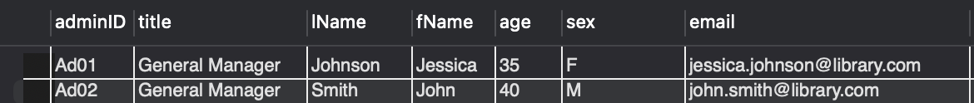

**Result Output:** As expected, mySQL Workbench executed scripts successfully in deleting row associating “Ad01”



**3/ Use case name:** Update an Administrator’s information (in this case: Job Title)

**Implementation:**

UPDATE Admin

SET title = 'Executive Manager'

WHERE adminID = 'Ad01';

**Expected Output:** Database Management System (DBS) should be able to take in new information to replace own information (“General Manager” of “Ad01” changes to “Executive Manager”



**Result Output:** As expected, mySQL Workbench executed scripts successfully in replacing job title of “Ad01” to “Executive Manager” as shown below.



**4/ Use case name:** Hire a new staff

**Implementation:**

INSERT INTO Staff (staffID, title, lName, fName, age, sex, email, branchID,hiredBy)

VALUES

('S01', 'Floor Staff', 'Lee', 'James', 25, 'M', 'james.lee@library.com', 'B01','Ad01');

**Expected Output:** DBS should be able to take in new information for Staff table

**Result Output:** DBS executes script successfully with new information associating with “S01” as shown below.

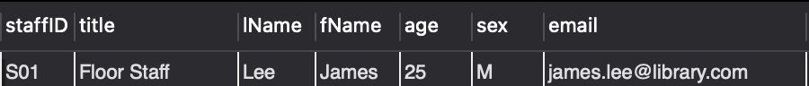

**5/ Use case name:** = Lay off a staff

**Implementation:**

DELETE FROM Staff

WHERE staffID = 'S01';

**Expected Output:** DBS should be able to delete row associating “S01”

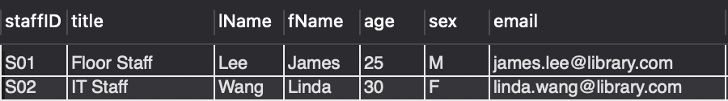

**Result Output:** As expected, DBS executed scripts successfully in deleting row associating “S01”

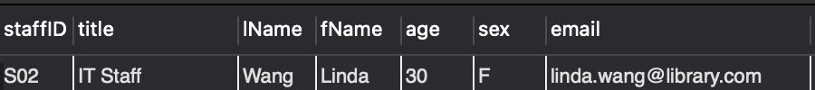

**6/ Use case name:** Update a staff’s information (in this case: Last name)

**Implementation:**

UPDATE Staff

SET lName = 'Holland'

WHERE staffID = 'S01';

**Expected Output:** DBS should be able to take in new information for staff with staffID “S01”



**Result Output:** As expected, DBS executes scripts successfully with new information in lName for staffID “S01”

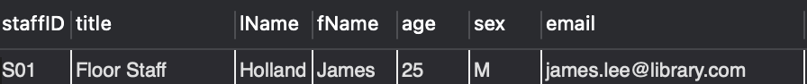

**7/ Use case name:** Add a new book

**Implementation:**

INSERT INTO Book (isbn, genre, title, branchID, status, publishedBy, language, shelf)

VALUES

('9781408894705', 'Fiction', 'The Testaments', 'B01', 'Available', 'Random House', 'English', 'Fiction A-Z');

**Expected Output:** DBS should be able to take in new information for the Book table.

**Result Output:** DBS executes script successfully with new information associating with ISBN “9780060883287” as shown below.



**8/ Use case name:** Delete a book

**Implementation:**

DELETE FROM book

WHERE isbn = '9781408894705';

**Expected Output:** DBS should be able to delete row associating “9780060883287” off the inventory



**Result Output:** As expected, DBS executed scripts successfully in deleting row associating “9780060883287” off the book inventory



**9/ Use case name:** Update an Book’s information (in this case: Book’s genre)

**Implementation:**

UPDATE Book

SET genre = 'Historical Fiction'

WHERE isbn = '9781408894705';

**Expected Output:** DBS should be able to take in new information for Book table with ISBN “9781408894705”



**Result Output:** As expected, DBS executes scripts successfully with new book’s genre as “Historical Fiction” for ISBN “9781408894705”



**10/ Use case name:** Register new member

**Implementation:**

INSERT INTO Member (memberID, lName, fName, age, sex, DOB, email, status, hold)

VALUES ('M01', 'Smith', 'John', 30, 'M', '1998-01-15', '555-1234', '[john.smith@email.com](mailto:john.smith@email.com)', ‘Active’ ‘0’);

**Expected Output:** DBS should be able to insert a new member into the Member table.

**Result Output:** DBS executes the script successfully, inserting the new member with memberID "M01" as shown below.



**11/ Use case name:** Request a book loan

**Implementation:**

INSERT INTO Request (requestID, memberID, status, staffID, date, time, branchID)

VALUES ('R01', 'M02', 'Pending', 'S03', '2023-01-20', '00:00:13', 'B05'');

**Expected Output:** DBS should be able to insert a new request into the Request table.

**Result Output:** DBS executes the script successfully, inserting the new request with requestID "R01" as shown below.

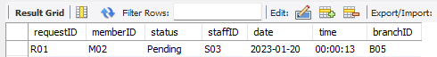

**12/ Use case name:** Approve/Deny book loan request from members

**Implementation:**

UPDATE Request

SET status = 'Approved'

WHERE requestID = 'R01';

**Expected Output:** DBS should be able to update the status of the request with requestID "R01" to "Approved".

**Result Output:** As expected, DBS executes the script successfully, updating the status of the request with requestID "R01" to "Approved" as shown below.

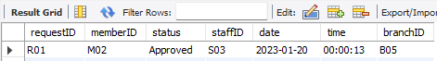

**13/ Use case name**: Renew/Cancel membership

**Implementation:**

UPDATE Member

SET membershipStatus = 'Expired'

WHERE memberID = 'M01';

**Expected Output:** DBS should be able to update the membership status of the member with memberID "M01" to "Expired".

**Result Output:** As expected, DBS executes the script successfully, updating the membership status of the member with memberID "M01" to "Expired" as shown below.



**14/ Use case name:** Insert Member

**Implementation:**

INSERT INTO Member (memberID, lName, fName, age, sex, DOB, email, status, hold)

VALUES ('M02', 'Doe', 'Jane', 30, 'F', '1993-04-19', 'janedoe@email.com', 'Active', ‘False’);

**Expected Output:** DBS should be able to insert a new member into the Member table.

**Result Output:** DBS executes the script successfully, inserting the new member with memberID "M02" as shown below.

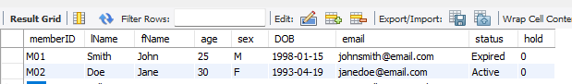

**15/ Use case name:** Delete Member

**Implementation:**

DELETE FROM Member

WHERE memberID = 'M02';

**Expected Output:** DBS should be able to delete the member with memberID "M02" from the Member table.

**Result Output:** As expected, DBS executes the script successfully, deleting the member with memberID "M02" from the Member table as shown below.

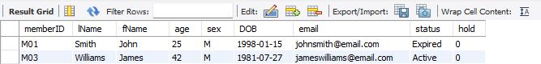

**16/ Use case name:** Update Member

**Implementation:**

UPDATE Member

SET age= 29

WHERE `= 'M01';

**Expected Output:** DBS should be able to update the age of the member with memberID "M01" to "29”.

**Result Output:** As expected, DBS executes the script successfully, updating the age of the member with memberID "M01" to "29" as shown below.

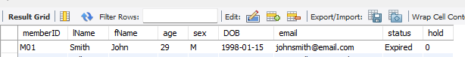

**17/ Use case name:** Insert Branch

**Implementation:**

INSERT INTO Branch (branchID, address, openHour, closeHour)

VALUES ('B02',456 Oak St, Houston, USA', 10:00:00', '18:00:00', ‘Mon-Sat);

**Expected Output:** DBS should be able to insert a new branch into the Branch table.

**Result Output:** DBS executes the script successfully, inserting the new branch with branchID "B02" as shown below.

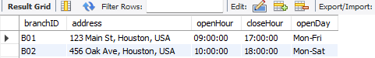

**18/ Use case name:** Delete Branch

**Implementation:**

DELETE FROM Branch

WHERE branchID = 'B02';

**Expected Output:** DBS should be able to delete the branch with branchID "B02" from the Branch table.

**Result Output:** As expected, DBS executes the script successfully, deleting the branch with branchID "B02" from the Branch table as shown below.

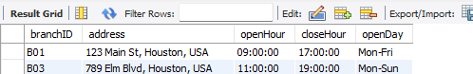

**19/ Use case name:** Update Branch

**Implementation:**

UPDATE Branch

SET address = '789 Oak Ave, Houston, USA'

WHERE branchID = 'B02';

**Expected Output:** DBS should be able to update the address of the branch with branchID "B02" to "789 Oak Ave, Houston, USA".

**Result Output:** As expected, DBS executes the script successfully, updating the address of the branch with branchID "B02" to "789 Oak Ave, Houston, USA" as shown below.

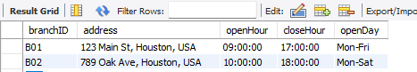

**20/ Use case name:** Insert Request Book

**Implementation:**

INSERT INTO Request (requestID, memberID, status, staffID, date, time, branchID)

VALUES ('R02', M13, Pending, 'S01', '2023-01-21', '00:00:15', 'B05'');

**Expected Output:** DBS should be able to insert a new request into the Request table.

**Result Output:** DBS executes the script

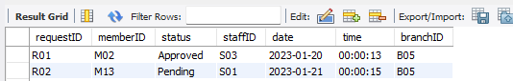

**21/ Use case name:** Delete Request Book

**Implementation:**

DELETE FROM Request

WHERE requestID = 'R02';

**Expected Output:** DBS should be able to delete the request with requestID "R02" from the Request table.

**Result Output:** As expected, DBS executes the script successfully, deleting the request with requestID "R02" from the Request table as shown below.

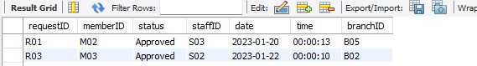

**22/ Use case name:** Update Request Book

**Implementation:**

UPDATE Request

SET status = 'Approved'

WHERE requestID = 'R01';

**Expected Output:** DBS should be able to update the status of the request with requestID "R01" to "Approved".

**Result Output:** As expected, DBS executes the script successfully, updating the status of the request with requestID "R01" to "Approved" as shown below.



**23/ Use case name:** Insert Order

**Implementation:**

INSERT INTO Order (requestID, isbn, borrowDate, returnDate, status, orderID, accuredFine)

VALUES (‘C02’, ‘R03’, ‘9780061231327’, ‘2023-01-22’, ‘2023-01-23’, ‘Returned’, ‘2023-01-29’, ‘0.00’);

**Expected Output:** DBS should be able to insert a new order into the Order table.

**Result Output:** DBS executes the script successfully, inserting the new order with orderID "C02" as shown below.

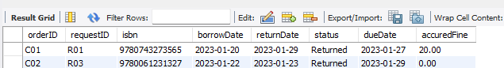

**24/ Use case name:** Delete Order

**Implementation:**

DELETE FROM Order

WHERE orderID = 'C02';

**Expected Output:** DBS should be able to delete the order with orderID "C02" from the Order table.

**Result Output:** As expected, DBS executes the script successfully, deleting the order with orderID "C02" from the Order table as shown below.

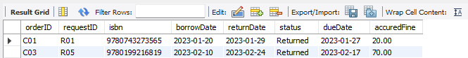

**25/ Use case name:** Update Order

**Implementation:**

UPDATE Order

SET accuredFine= 40.00

WHERE orderID = 'C01';

**Expected Output:** DBS should be able to update the quantity of the order with orderID "C01" to 40.00.

**Result Output:** As expected, DBS executes the script successfully, updating the quantity of the order with orderID "C01" to 40.00 as shown below.

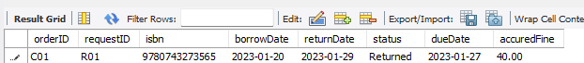

**26/ Use case name:** Insert Register

**Implementation:**

INSERT INTO Register (username, password, staffID, memberID)

VALUES (‘Adams.James.456’, ‘MemberJames60’, NULL, ‘M20’)

**Expected Output:** DBS should be able to insert a new register into the Register table.

**Result Output:** DBS executes the script successfully, inserting the new register with as shown below.

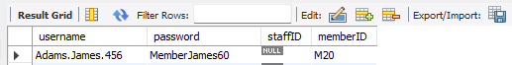

**27/ Use case name:** Delete Register

**Implementation:**

DELETE FROM Register

WHERE memberID= 'M20';

**Expected Output:** DBS should be able to delete the register with memberID= 'M20' from the Register table.

**Result Output:** As expected, DBS executes the script successfully, deleting the register with memberID= 'M20' from the Register table as shown below.

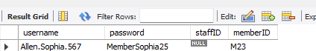

**28/ Use case name:** Update Register

**Implementation:**

UPDATE Register

SET passowrd= 'MemberJames4698!’

WHERE memberID= 'M20';

**Expected Output:** DBS should be able to update the password with memberID= 'M20' to 'MemberJames4698!

**Result Output:** As expected, DBS executes the script successfully, updating the password with memberID= 'M20' to 'MemberJames4698!

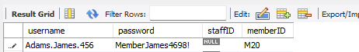

**29/ Use case name:** Determine where the book locates and the status of that book

**Implementation:**

SELECT Book.isbn, book.title, book.status, Branch.branchID AS availableAt, Branch.address

FROM Offer

INNER JOIN Book ON Offer.isbn = Book.isbn

INNER JOIN Branch ON Offer.branchID = Branch.branchID;

**Expected Output:** DBS should be able to return books information along with its location, this can be done in large batches or a specific book.

**Result Output:** DBS was not able to return correct information with below error



**Solution:** Since Branch.location is not in the field list, it should be Branch.address.

**Solution Output:** As expected, the error was correct. DBS execute scripts successfully with below results.

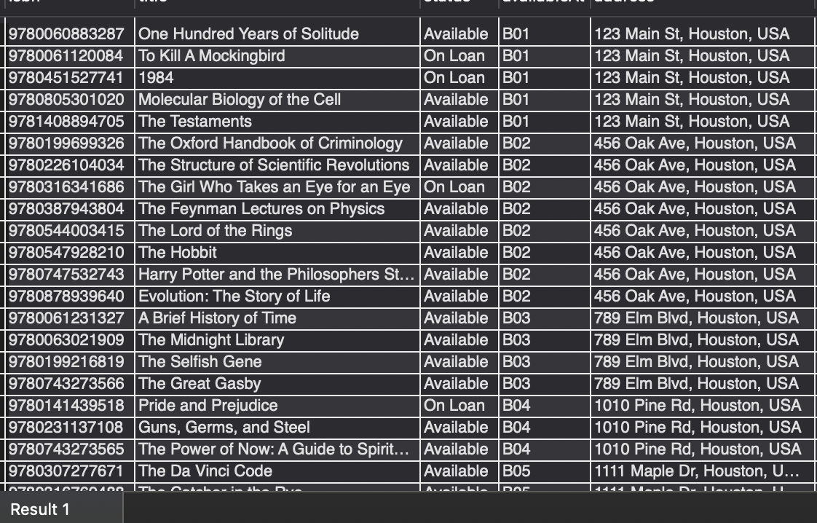

**30/ Use case name:** Determine who hires staffs to coordinate staffs

**Implementation:**

SELECT Admin.adminID, Admin.title, Admin.lName, Admin.fName, Staff.staffID AS hiredBy, Staff.title AS hiredTitle, Staff.lName, Staff.fName

FROM Hiring

INNER JOIN Staff ON Hiring.staffID = Staff.staffID

INNER JOIN Admin ON Hiring.adminID = Admin.adminID;

**Expected Output:** DBS should be able to show a table consisting of staff and who hired them with their names.

**Result Output:** As expected, DBS executes scripts successfully with below results showing staff and administration information.

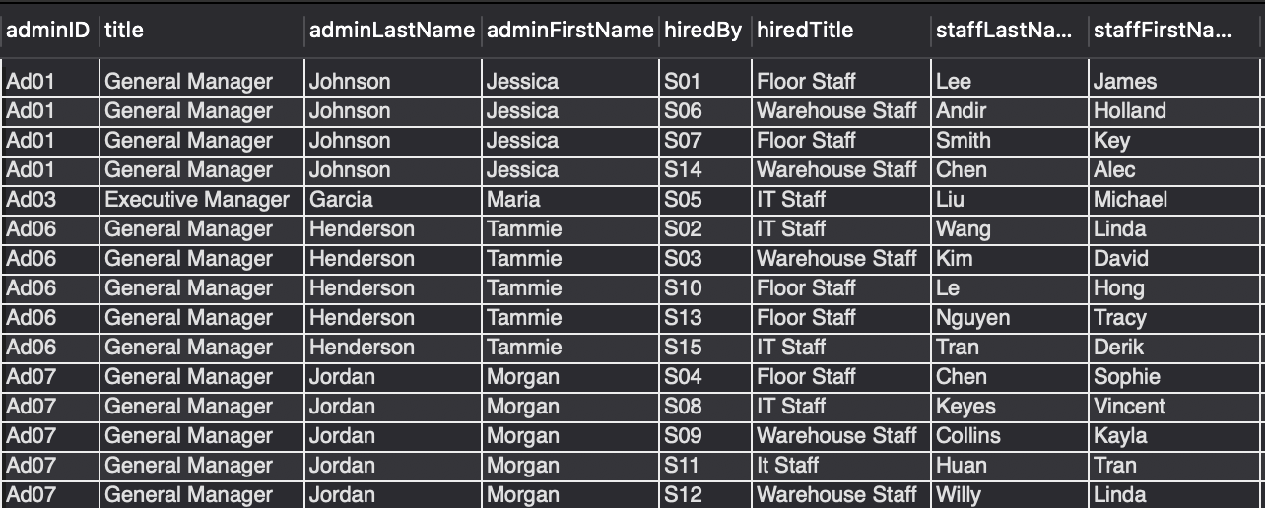

**31/ Use case name:** Check who wrote books in the library inventory

**Implementation:**

SELECT Book.isbn, Book.title, Author.authorID, Author.lName, Author.fName

FROM WrittenBy

INNER JOIN Book ON WrittenBy.isbn = Book.isbn

INNER JOIN Author ON WrittenBy.authorID = Author.authorID;

**Expected Output:** DBS should be able to show a table consisting of books along with their associating authors including multiple authors

**Result Output:** As expected, DBS executes scripts successfully with below results showing books and their information including their authors.

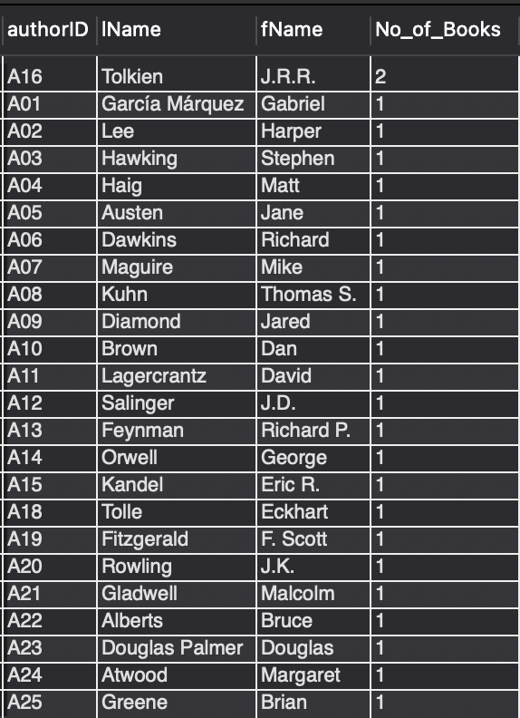

**32/ Use case name:** Report the average age of staff for a census

**Implementation:**

SELECT AVG(age) AS average_age_staff

FROM Staff;

**Expected Output:** DBS should be able to export data that can be exported to an .csv file.

**Result Output:** As expected, DBS executes scripts successfully with below results showing the average age of staff roster.

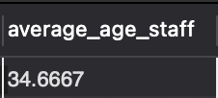

**33/ Use case name:** Print our total open hour of each branch for advertisement

**Implementation:**

SELECT branchID, closeHour, openHour, SEC_TO_TIME( SUM( TIME_TO_SEC( closeHour - openHour ) ) ) AS total_Open_Hour

FROM Branch

GROUP BY branchID;

**Expected Output:** DBS should be able to export data that can be exported to an .csv file.

**Result Output:** Error, DBS was not able to produce data for total open hours of each branch with syntax error.

**Solution:** Use this script to convert time to correct format.



**Solution Output:** As expected, new scripts were carried out successfully exporting correct data.

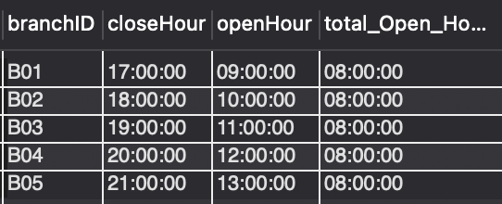

**34/ Use case name:** Determine how many books there are in the library

**Implementation:**

SELECT COUNT(isbn) AS total_book

FROM Book;

**Expected Output:** DBS should be able to show the total books in the inventory.

**Result Output:** As expected, DBS executes scripts successfully with below results.

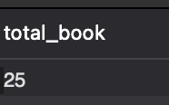

**35/ Use case name:** Report the number of females and males administrator within the library system for a census

**Implementation:**

SELECT sex, COUNT(*) AS total

FROM Admin

GROUP BY sex;

**Expected Output:** DBS should be able to show the total male and female in the administrator roster.

**Result Output:** As expected, DBS executes scripts successfully with below results.

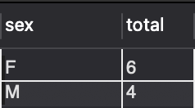

**36/ Use case name: C**heck the most expensive accrued fine in the library system

**Implementation:**

SELECT orderID, requestID, accuredFine

FROM `Order`

WHERE accuredFine = (SELECT MAX(accuredFine) FROM `Order`);

**Expected Output:** DBS should be able to show which orderID has the highest accrued fine.

**Result Output:** Error. Instead of showing orderID with the highest accrued fine, DBS returns every member sorted by accrued fine.

**Solution:** Specify target by using this script.

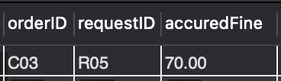

**37/ Use case name:** Determine total request by status inspecific period of time

**Implementation**:

SELECT status, COUNT(*) as totalOrder

FROM Request

WHERE date >= '2023-01-01' AND date <= '2023-03-31'

GROUP BY status;

**Expect Output:** DBS should show the total number of orders base on status

**Result Output:** DBS does show the total number of orders base on status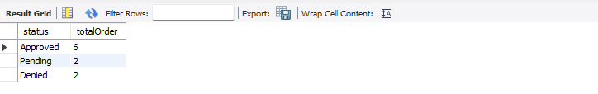

**38/ Use case name:** Determine total author

**Implementation:**

SELECT COUNT(DISTINCT CONCAT(lName, fName)) as TotalAuthor

FROM Author;

**Expect Output:** DBS should show the total number of author

**Result Output:** DBS does show the total number of author

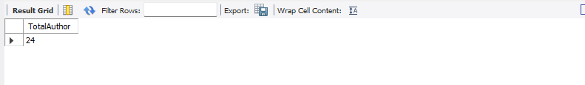

**39/ Use case name**: Determine which admin manage which library branch

**Implementation**:

SELECT

m.adminID,

a.fName AS adminFristName,

a.lName AS adminLastName,

a.title AS title,

m.branchID,

b.address AS branchAddress

FROM

Manage m

INNER JOIN Admin a ON m.adminID = a.adminID

INNER JOIN Branch b on m.branchID = b.branchID

**Expect Output:** DBS should show admins’ name and the library branch that they work at

**Result Output:** DBS does show admins’ name and the library branch that they work at

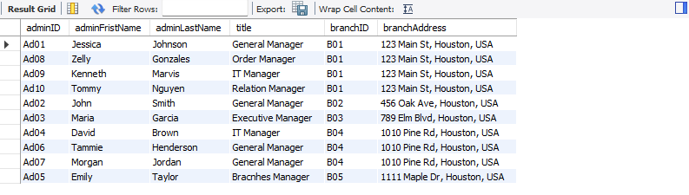

**40/ Use case name**: Determine total of staff with specific title in each branch

**implementation**:

SELECT

p.branchID,

b.address AS branchAddress,

s.title as staffTitle,

COUNT(*) AS numberOfEmployee

FROM

primaryBranch p

INNER JOIN Staff s ON p.staffID = s.staffID

INNER JOIN Branch b on p.branchID = b.branchID

GROUP BY p.branchID, s.title;

**Expect Output:** DBS should the number of staff with specific titles in a specific branch.

**Result Output:**  DBS does the number of staff with specific titles in a specific branch.

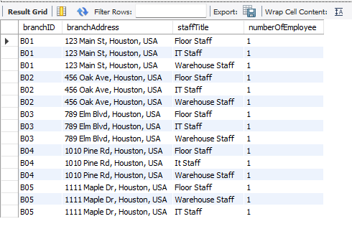

**41/ Use case name:** View order detail

Implementation:

SELECT

o.orderID,

r.requestID,

br.address AS LibraryAddress,

s.staffID,

s.fName AS staffFristName,

s.lName AS staffLastName,

m.memberID,

m.fName AS memberFristName,

m.lName AS memberLastName,

r.date AS requestDate,

r.time AS requestTime,

b.isbn AS bookISBN,

b.title AS bookTitle,

o.borrowDate,

o.dueDate,

o.returnDate,

o.status AS orderStatus,

o.accuredFine

FROM `Order` o

INNER JOIN Request r on o.requestID = r.requestID

INNER JOIN Book b on o.isbn = b.isbn

INNER JOIN Member m on r.memberID = m.memberID

INNER JOIN Staff s on r.staffID = s.staffID

INNER JOIN Branch br on r.branchID = br.branchID;

**Expect Output:** DBS should show order in specific details which are extract from foreign key

**Result Output:** DBS does show order in specific details which are extract from foreign key

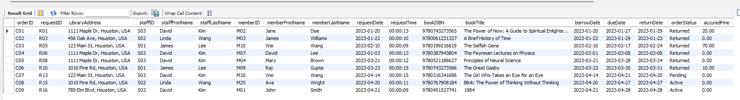

# Conclusion

In conclusion, this comprehensive report has provided an in-depth analysis and documentation of the database design and implementation for the library management system. We have meticulously covered various aspects of the database, including defining the library's entities and relationships, creating tables with appropriate keys and constraints, and designing a robust and scalable database structure.

Throughout the development process, we have ensured the reliability and functionality of the database system by testing it using 41 specific use cases, which span a wide range of library management system features. These use cases include, but are not limited to, managing books and authors, member registration and management, staff hiring and scheduling, library branch management, and the tracking of various library activities like book requests, loans, and returns.

The successful execution of these use cases validates the database design's effectiveness and ability to handle complex operations and tasks. In cases where errors were encountered, we promptly identified the issues and provided appropriate solutions, ensuring that the final implementation performed as expected. The ability of the database system to handle these use cases demonstrates its adaptability and reliability in meeting the library's operational requirements.

Moreover, the library management system's database design is structured to promote easy maintenance, expansion, and scalability. As the library's needs evolve, the database system can be refined and enhanced to accommodate new features, services, and requirements. This adaptability ensures that the library management system remains relevant and effective in the face of changing demands and technological advancements.

In addition to the technical aspects, we have also addressed the importance of data integrity and security. The database design includes constraints and rules that help maintain the accuracy and consistency of the data. These measures ensure that the library staff can rely on the system to provide accurate, up-to-date, and trustworthy information for their day-to-day tasks and make informed decisions.

Finally, the user-friendly interface and the comprehensive functionality provided by the library management system will enhance the overall experience for both library staff and members. The system offers a streamlined and efficient way to manage and access library resources, ultimately fostering a positive learning, research, and personal growth environment.

In summary, the library management system's database design and implementation have proven to be efficient, reliable, and adaptable, making it an invaluable tool for library staff and members alike. As the library continues to grow and evolve, the database system will serve as a solid foundation for new features and enhancements, ensuring the library remains a vital and supportive resource for its community.

# References

Admin. (2021, October 22). *The Importance of the Library for Students*. Kitab Center. https://kitabcenter.com/the-importance-of-the-library-for-students/#:~:text=Libraries%20are%20the%20best%20place%20for%20children%20to

*library database objective*. (n.d.). Bing. Retrieved April 28, 2023, from https://www.bing.com/search?q=library+database++objective&qs=n&form=QBRE&sp=-1&ghc=1&lq=0&pq=library+database++objectiv&sc=6-26&sk=&cvid=E205EACEC1F94FBBB43F3B1A66739C2D&ghsh=0&ghacc=0&ghpl=

W3Schools. (2019). *SQL Tutorial*. W3schools.com. https://www.w3schools.com/sql/default.asp